Exercise 3 – Implementing Logging using Spring AOP

Name: Shubham Sangram Bej

Aim
To implement logging in a Spring application using Aspect-Oriented Programming (AOP) and demonstrate cross-cutting concerns through Spring AOP.

Objective
- To understand the concept of Spring AOP.
- To implement logging using AspectJ annotations.
- To intercept method execution before business logic.
- To configure AOP using Java Configuration.

Software Requirements
- Java JDK 21
- IntelliJ IDEA
- Apache Maven
- Spring Framework 5.x
- Spring AOP
- AspectJ Weaver

Theory
Aspect-Oriented Programming (AOP) is a programming paradigm used to separate cross-cutting concerns such as logging, security, and transaction management from business logic. Spring AOP allows developers to apply additional behaviour to methods without modifying their source code.
In this exercise, a logging aspect is created using the @Aspect annotation. A @Before advice executes before the target method, displaying a log message whenever the business method is invoked.

Project Components

BookService
Contains the business method responsible for issuing a book.

LoggingAspect
Implements logging functionality using Spring AOP. The aspect intercepts service methods before execution.

SpringConfig
Provides Java-based Spring configuration, enabling component creation and AspectJ auto-proxy support.

LibraryApplication
Loads the Spring ApplicationContext and invokes the service bean.

Procedure
- Created a Maven project.
- Added Spring Context, Spring AOP, and AspectJ Weaver dependencies.
- Created the BookService class.
- Created the LoggingAspect class with @Aspect and @Before.
- Configured Spring using SpringConfig.
- Loaded the Spring context.
- Executed the application and verified the logging output.

Output

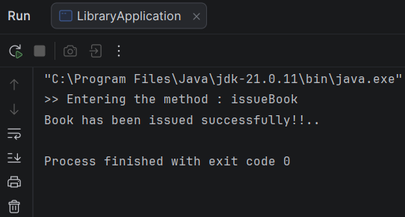

Screenshots
- Project Structure
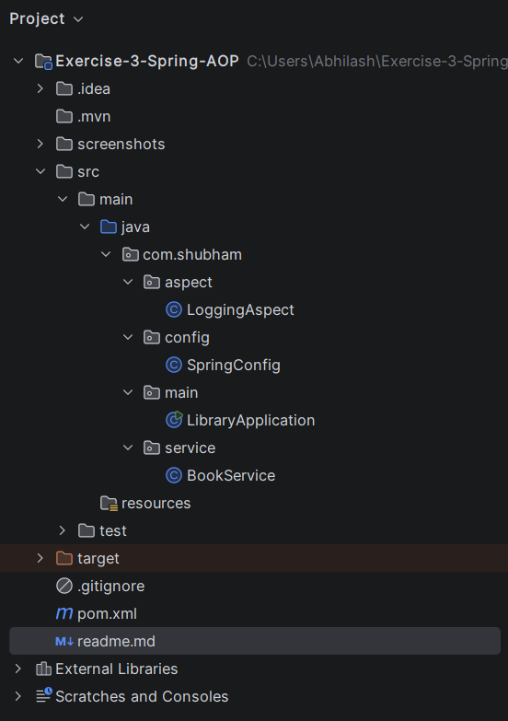

- pom.xml
<?xml version="1.0" encoding="UTF-8"?>
<project xmlns="http://maven.apache.org/POM/4.0.0"
xmlns:xsi="http://www.w3.org/2001/XMLSchema-instance"
xsi:schemaLocation="http://maven.apache.org/POM/4.0.0
https://maven.apache.org/xsd/maven-4.0.0.xsd">
<modelVersion>4.0.0</modelVersion>
<groupId>com.shubham</groupId>
<artifactId>exercise-3-spring-aop</artifactId>
<version>1.0-SNAPSHOT</version>
<properties>
<maven.compiler.source>21</maven.compiler.source>
<maven.compiler.target>21</maven.compiler.target>
<spring.version>5.3.39</spring.version>
</properties>
<dependencies>
<dependency>
<groupId>org.springframework</groupId>
<artifactId>spring-context</artifactId>
<version>${spring.version}</version>
</dependency>
<dependency>
<groupId>org.springframework</groupId>
<artifactId>spring-aop</artifactId>
<version>${spring.version}</version>
</dependency>
<dependency>
<groupId>org.aspectj</groupId>
<artifactId>aspectjweaver</artifactId>
<version>1.9.22</version>
</dependency>
</dependencies>
</project>

- LoggingAspect.java
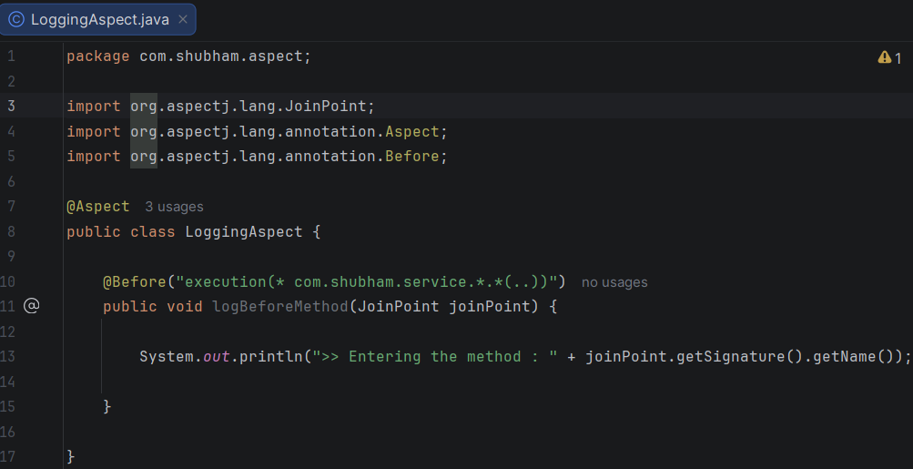
- BookService.java
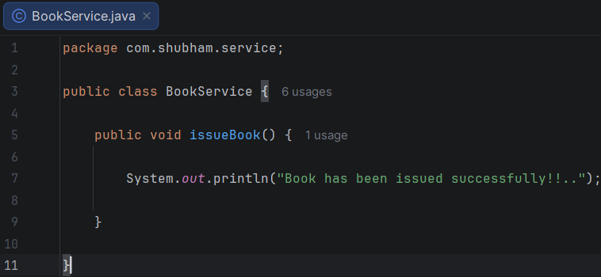

- SpringConfig.java
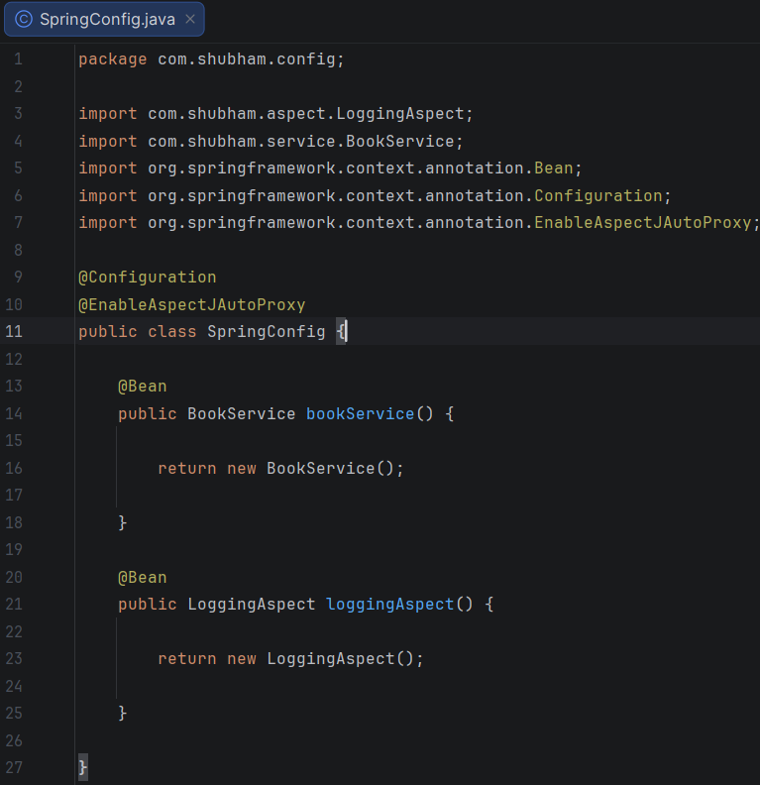
- LibraryApplication.java
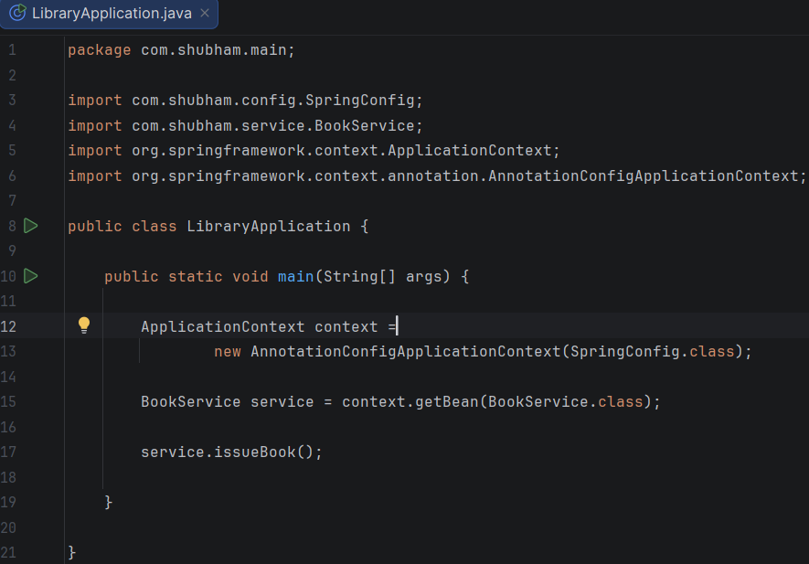

Result
The application successfully demonstrated logging using Spring AOP. The aspect intercepted the service method before execution and displayed the logging message without modifying the business logic.

Conclusion
The experiment successfully demonstrated Aspect-Oriented Programming using Spring Framework. Logging functionality was implemented as a cross-cutting concern using AspectJ annotations, resulting in cleaner, modular, and more maintainable code.

